**Ideation Phase**

**Define the Problem Statements**

|  |  |  |  |  |  |
| --- | --- | --- | --- | --- | --- |
| **Problem**  **Statement (PS)** | **I am**  **(Customer)** | **I’m trying to** | **But** | **Because** | **Which makes me feel** |

|  |  |
| --- | --- |
| Date | 23 OCTOBER 2022 |
| Team ID | PNT2022TMID241222 |
| Project Name | GAS LEAKAGE MONITORING AND ALERTING SYSTEM FOR INDUSTRIES |
| Maximum Marks | 2 Marks |

|  |  |  |  |  |  |
| --- | --- | --- | --- | --- | --- |
| PS-1 | Industrialist | Monitor gas leakage in the industry | I don’t have  any system for monitoring | The affordable of the system is high and the systems are sometimes making disasters | Unsafe |

Domestically we use natural gas and it is very useful for burning purposes. If this gas is leaked in our kitchens, offices or factories and not sensed in time, it may lead to a fatal disaster, and may cause human loss. For this purpose, we came forward with an idea of making such an electronic device to sense that leakage and alarm the respective persons to solve that leakage problem and save assets and human lives. It also down our economical rate.

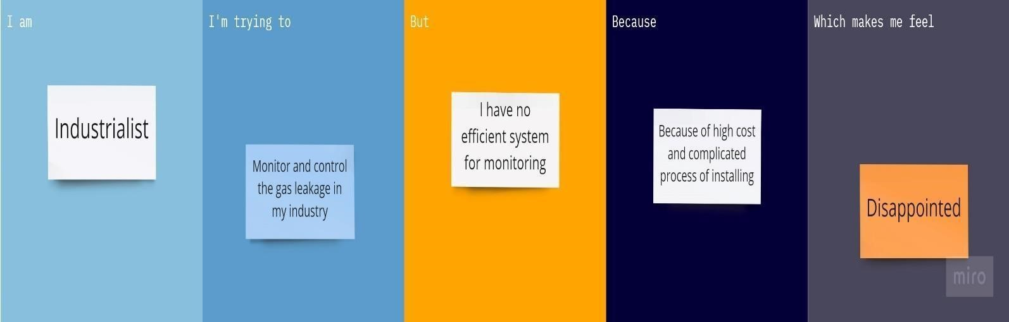

|  |  |  |  |  |  |
| --- | --- | --- | --- | --- | --- |
| PS-2 | Industrialist | Control the gas leakage | Also, the installation process is too complicated | The number of sensors is unpredictable and the positioning of equipment is improper | Disastrous |